TERMS OF REFERENCE AND SCOPE OF ACTIVITIES
FINANCIAL EXPERT 1
FOR
SERBIA SCALING UP RESIDENTIAL CLEAN ENERGY (SURCE) PROJECT

Background
The Government of the Republic of Serbia (GoS) has secured financing from the International Bank for Reconstruction and Development (IBRD), which is part of the World Bank Group, to implement the Serbia ‘Scaling Up Residential Clean Energy’ (SURCE) Project, hereinafter the “Project”. The development objective of the Project is to increase the uptake of energy efficiency (EE), sustainable heating, and rooftop solar photovoltaics (RSPV) by households in participating local self-government units (LSGUs) in Serbia. An important associated objective is to reduce greenhouse gas (GHG) emissions and improve air quality thanks to achieved energy savings and reduced use of solid fuels for heating. These objectives will be achieved by two project components:
- Component 1: Financing Energy Efficiency, Sustainable Heating, and Rooftop Solar Investments in Residential Buildings, with a key focus on single-family houses (SFHs).
- Component 2: Technical Assistance and Implementation Support, with the overall aim of supporting the development of scalable financing mechanisms and removing market barriers, with three subcomponents: (a) enhancing local market capacity, improving enabling environment, and strengthening public awareness; (b) technical studies informing program design and implementation; and (c) project implementation support.

Components 1 and 2 will be implemented simultaneously; together they represent USD 50 million with Component 1 being allocated the major share of loan proceeds. Investments will be financed under Component 1 and scaled up relying on the analytical insights, institutional structures, and financing mechanisms developed under Component 2. The Ministry of Mining and Energy (MoME) might provide additional funds from the government budget to expand the scope of the investments.

The project will scale up a revised version of an existing government program, piloted in 2021, financing residential EE investments through a combination of public grants and leveraged private-sector financing. The investments under Component 1 will be financed through: (a) partial grants financed through the Project, offered by the MoME and channeled through participating local self-governing units (LSGUs); (b) partial grants offered by the LSGUs directly, in parallel with the IBRD financing channeled through the Project; and (c) household contributions, financed either from savings or borrowings (Figure 1).

Figure 1. Structure of the Project, with the LSGU playing a pivotal role and the citizen required to pay a share of the investment

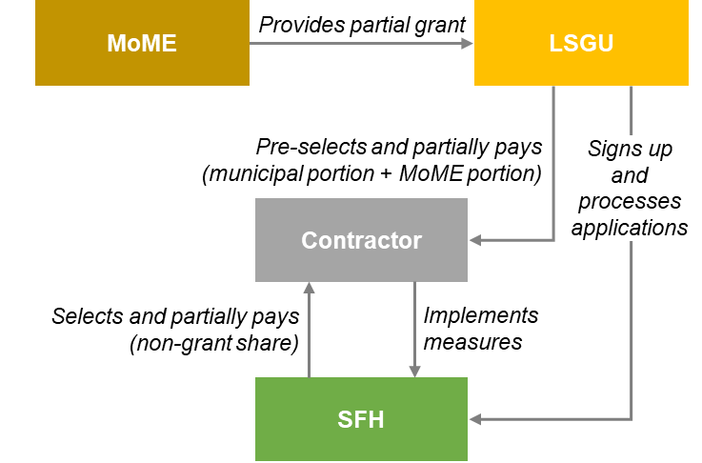

Notes: MoME: Ministry of Mining and Energy; SFH: single-family house; LSGU: Local self-government unit.
Source: World Bank staff.

The Project became effective in December 2022 and will be implemented over a 5-year period until November 2027. The overall responsibility for implementation of the Project rests with the Government of Serbia, with the MoME acting as implementing entity. The MoME will establish a Project Implementation Unit (PIU) to carry out the day-to-day activities of Project implementation. The PIU will coordinate closely with the MoME as well as the World Bank energy team responsible for the Project implementation on IBRD side. SURCE implementation will be also facilitated by the Administration for Energy Efficiency Financing and Promotion (hereinafter Energy Efficiency Administration, EEA) which has a coordinating role for clean energy and energy efficiency programs across government.

The Ministry of Finance (MoF) will provide SURCE Loan Agreement oversight and serve as the financial guarantor for all IFI-funded projects. The Central Fiduciary Unit (CFU), housed within the Ministry of Finance, will assist the SURCE PIU in the implementation of the financial management arrangements of the Project including planning and budgeting, accounting, financial reporting, flow of funds (including disbursement), internal controls, and external auditing, ensuring that these activities are carried out in line with the World Bank procedures.
The MoME intends to engage a consultant to take on the assignment of an Financial Expert 1 in the PIU (hereunder the Consultant). A part of the proceeds of the IBRD loan will be used for financing the proposed consultancy assignment. These Terms of Reference define the scope of activities and responsibilities of the Consultant. Additional PIU staff will be recruited under separate TORs for key positions and will include, among others, the Head of the PIU, an engineer, an environmental and social safeguard expert, and an IT expert.

Objective of the assignment
The objective of this assignment is to participate in the financial aspects of activities under the Project with a particular focus on financial management with relation to the involvement of LSGUs.

Scope of Work
The Consultant will be responsible for:
- Financial management of the Project using a Project financial management system acceptable to the World Bank that will be established in close coordination with the CFU. The Consultant will be responsible for processing and monitoring LSGU related aspects, including processing payments to LSGUs, monitoring financial flows and spending by LSGUs in line with contract provisions, verification of financial documents related to the project, collecting and reviewing LSGU financial reports,analyzing project’s spendings and other financial data and making recommendations and preparing requests for payment and yearly operating costs plan and training plan. The consultant will also be performing tax and customs examptions in accordance with the provisions of the Loan Agreement and preparing calculations of official business trips.
- Performing support activities related to financial reporting, which includes the establishment, in close coordination with the CFU, of a regular reporting protocol that will be able to produce information at LSGU level about the Financial Management as stipulated in the Project Loan Agreement and Project Operation and Grant Manual (POGM) or as may be from time to time requested by the World Bank, MoME, or the Energy Efficiency Administration (EEA). It is the CFU that will be responsible for preparing applications for withdrawal of Loan proceedsSimilarly, the CFU will be the unit which will prepare quarterly interim unaudited financial reports and yearly Financial Statements, with the PIU expert expected to obtain LSGU level financial reports and other relevant information. Consultant will prepare and submit to the CFU Overall Report on documentation of each grant, on quarterly basis.

- Coordinating inputs to the Project management, monitoring and reporting system:
- Review the submissions from the LSGUs
- Assess the financial costs and savings that will result from application of energy efficiency, sustainable heating and RSPV investments in SFHs:
  - Support the Project Engineer’s to conduct financial analyses that include review of the investment costs, possible returns on investments and conduct a cost-benefit analysis of the measures implemented under the Project;
  - Train and provide ongoing assistance to LSGs committee members;
  - Carrying out the process of procurement of goods and services on the Project.

Reporting
The Consultant will report to the Head of the PIU under the MoME and will coordinate closely with the other Financial Experts of PIU..
Assignment duration
The Consultant shall provide full-time services for the life of the Project, i.e. until November 30, 2027 as currently planned, with a probationary period of six (6) months. The Consultant shall not be involved in another assignment that represents a conflict of interest to the prevailing assignment.
Qualification Requirements
The nominee for the position should possess the following qualifications:
- University degree in finance, economics or related field with at least 240 ECTS points or equivalent (Bachelor Academic Studies, in the scope of at least 240 ECTS points, Master Academic Studies, Specialist Academic Studies, Specialist Vocational Studies, i.e. at Bachelor studies lasting at least four years or Specialist Academic Studies at the University)
- At least 5 years of work experience in the field of financial management.
- Working experience for public administration would be an advantage
- Experience in programs financed by IFIs will be an advantage.
- Experience in performing financial analysis including cost-benefit or ROI analyses would be an advantage.
- Demonstrated ability to deliver when working under pressure and within changing circumstances.
- Knowledge of computer, office software and web-based applications use.
- Good writing/reporting skills.
- Good interpersonal skills.
- Excellent knowledge of written and spoken Serbian and English.
Evaluation criteria
The candidates will be evaluated applying the following evaluation criteria:
- General experience ( 40 Points)
- Specific Experience relevant to the Assignment ( 60 Points)
Expected Outputs
Suport in financial aspects for the quarterly project management reports, twice-annual progress reports, annual budgets and work plans, and mid-term review documentation. Provide necessary inputs for day-to-day management of the financial and economic aspects of the Project, and assistance in preparation of ad hoc reports and papers as the needs of the Project require.
Input by the MoME
The MoME will provide the Consultant with complete office infrastructure, the required equipment, access to any documentation and information necessary for the performance of his / her tasks.
Procurement Regulation
The attention of interested Consultants is drawn to paragraph 3.14, 3.16 and 3.17 of the World Bank’s Procurement Regulations for Investment Project Financing (IPF) Borrowers, Procurement in Investment Project Financing Goods, Works, Non-Consulting, and Consulting Services (updated November 2020) setting forth the World Bank’s policy on conflict of interest. The type of contract will be time-based contract.

A Consultant will be selected in accordance with the Open Competitive Selection of Individual Consultants as set out in the World Bank’s Procurement Regulations. The type of contract will be time-based contract.

The system will be established for the Project on the basis of similar systems used in other Bank financed projects. The system is to include an accounting and control module with the capability to record and retrieve in a timely manner all financial transactions under the Project.

